Brandon Hill and Ashkon Bashkar

Period 5

AP COMPSI

February 8, 2017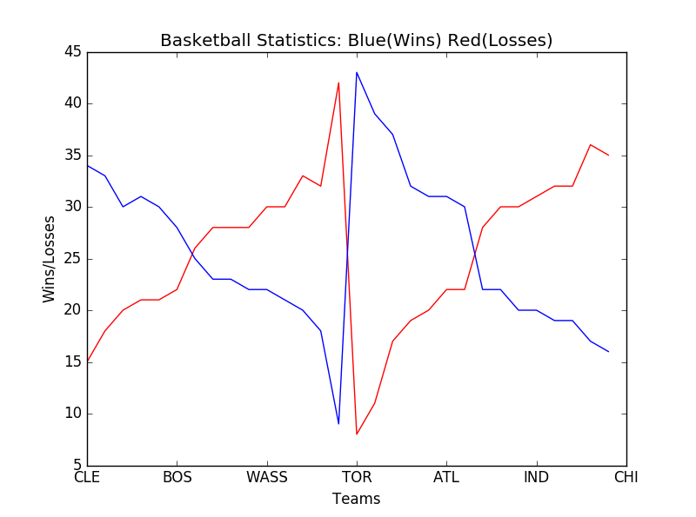

The question we have received was does a brutal loss usher to a continuous losing streak in future games and if so, how do these early losses affect future matchups? Not needing to revise the question in anyway, there was a continuation of the search. In the data gathered, it can be confirmed that a brutal loss ushered will most likely result in a continuous losing streak in future games. In the data, there is a pattern within the teams Win/Lose ratios. As there is an increase in wins, there is a decrease in losses. However, when there is a decrease in wins, there is an increase in losses that seems to continue amongst the different teams. The teams with the most wins have significantly less losses than the teams with the least number of wins. A cause of this could be the player’s motivation. Usually when a team loses, the hopes of the team are a bit down. So, if they continuously lose, the team’s hopes of winning will go down and then they will lose even more games. So, it is most likely that a loss will coincide with a continuous losing streak. Take a good look at the data before placing your bets!

Some lurking variables found were rising stars. There could possibly be a new player on the rise that might have possibly started on one of the teams on the losing team. If that player is good enough, there is a possibility that that player could carry the team to victories. Another lurking variable we found was absent players due to injury or sickness. This is a possibility because since the top teams have some of the best players out there, what if there star players get taken out due to injury or sickness? This would give the weaker teams to possibly win more games and ultimately changing the data.